Installation/Back-up instructions

-Group Membership: **Group 11**

* 1. Kuang-I, Ho / 041096978 / [ho000104@algonquinlive.com](mailto:ho000104@algonquinlive.com)
  2. Seabyul Yun / 041091398 / [yun00014@algonquinlive.com](mailto:yun00014@algonquinlive.com)
  3. Jason Zhang / 041096314 / [zhan0820@algonquinlive.com](mailto:zhan0820@algonquinlive.com)

1. Launch SQL Server Management Studio (SSMS) and connect to your SQL Server instance.

2.Connect using your Windows login account.

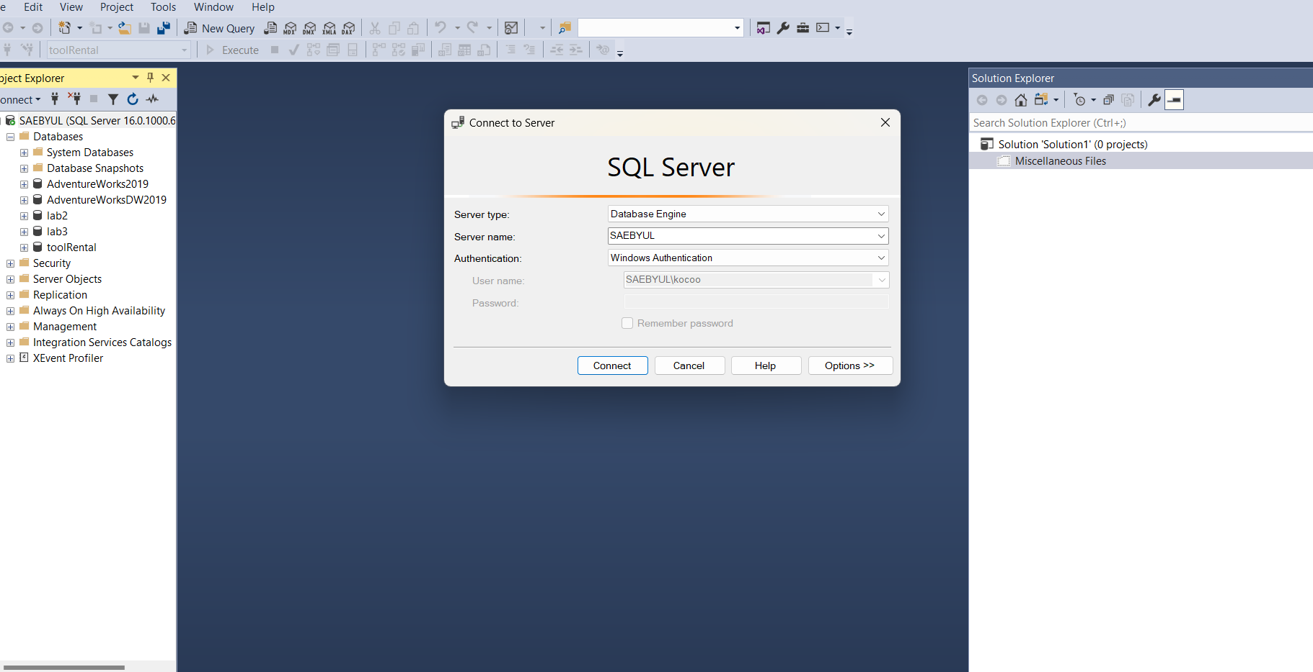

3.Right-click the on “toolRental”, point to **Tasks**, and then select “**Back Up”**

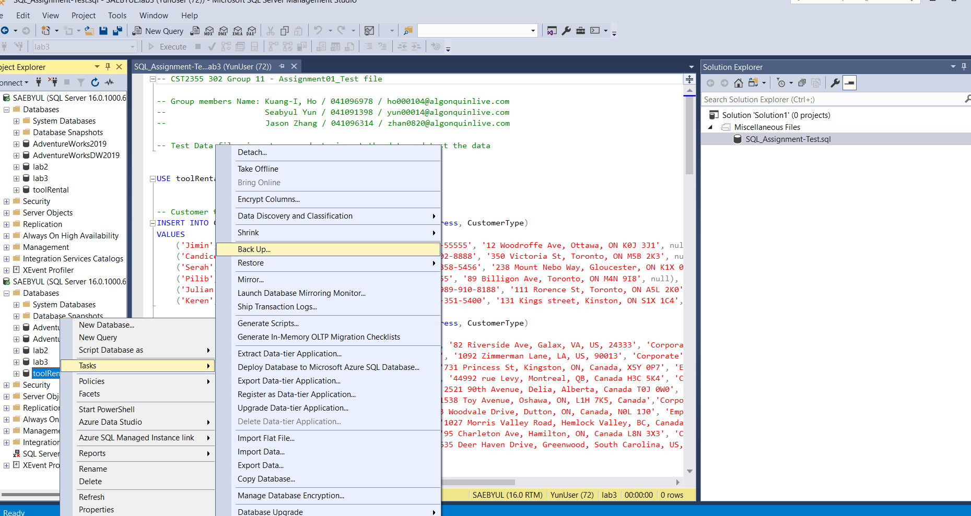

4. Select the “Copy Only” option.

6.When the backup completes successfully, select **OK**

7. Check the back-up file in C:\Program Files\MicrosoftSQLServer\MSSQL16.MSSQLSERVER\MSSQL\Backup

